Step1 - Application starts by displaying the login page for the administrator to login in

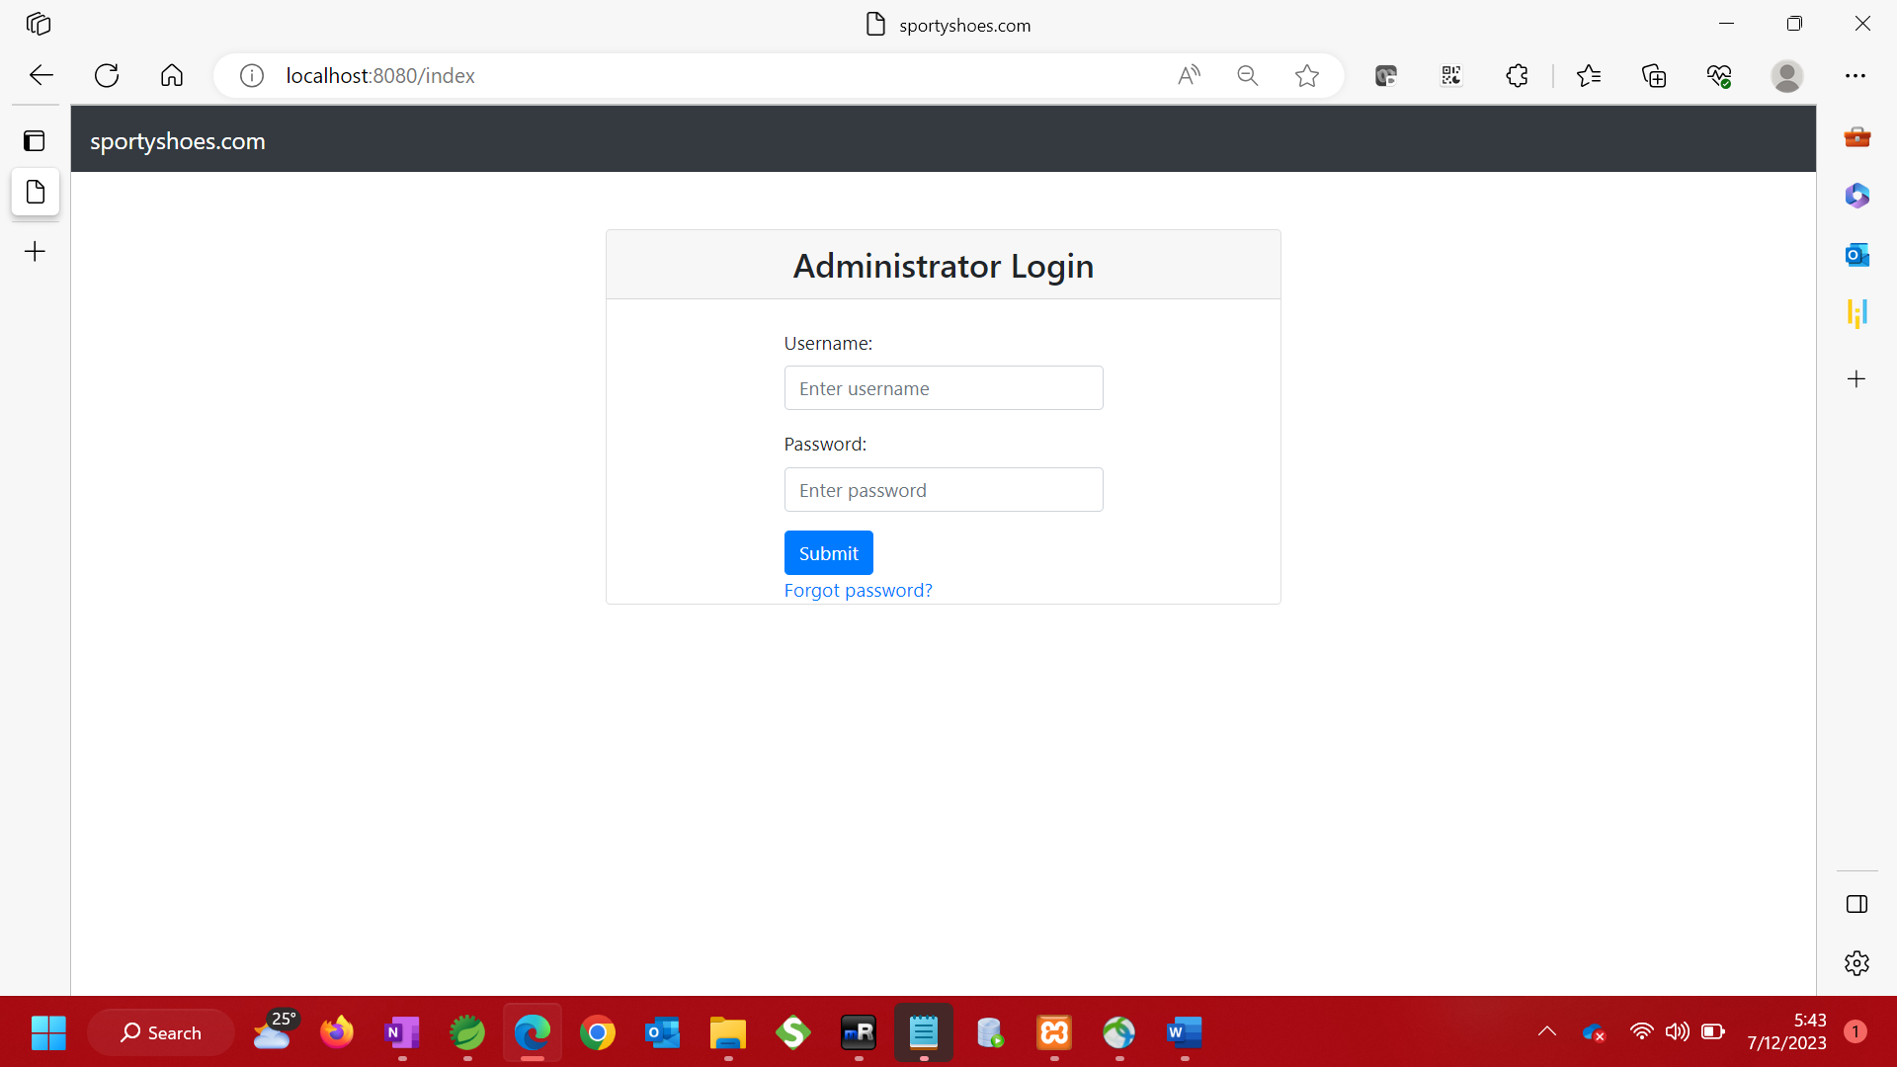

Step 2: Take user input and check if credentials are correct. Stay on login page and show error message if credentials are not correct.

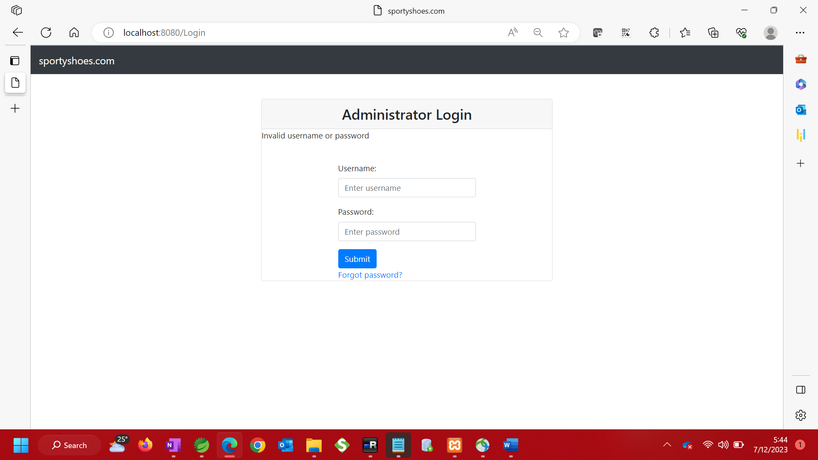

Step3. Display dashboard page with menu items if credentials are correct

|  |
| --- |
|  |

Step 4 – Select an item from the menu options

1. Add Products to inventory

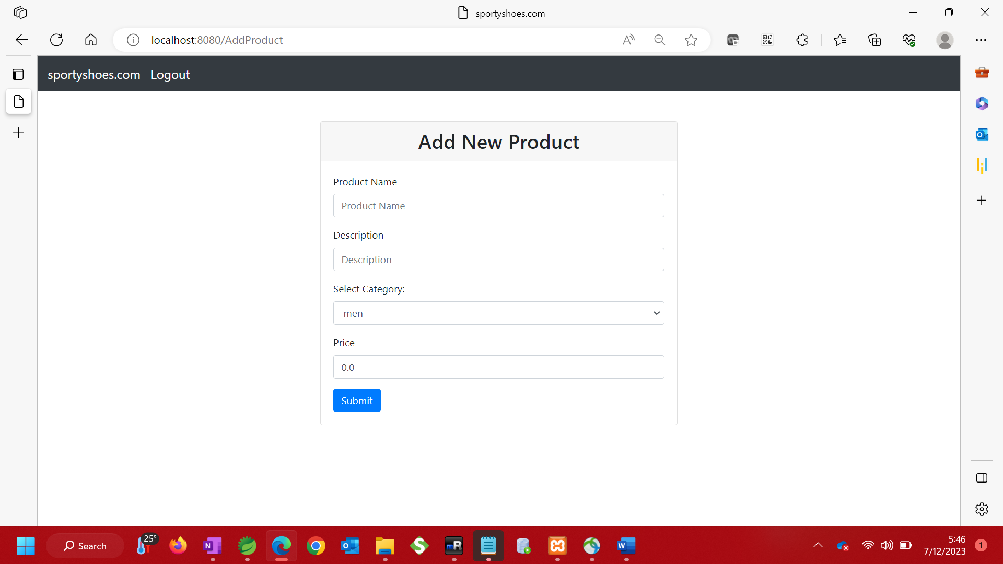

1. Validate input to ensure field is not empty on submission. If input is empty, stay on same page and display message.

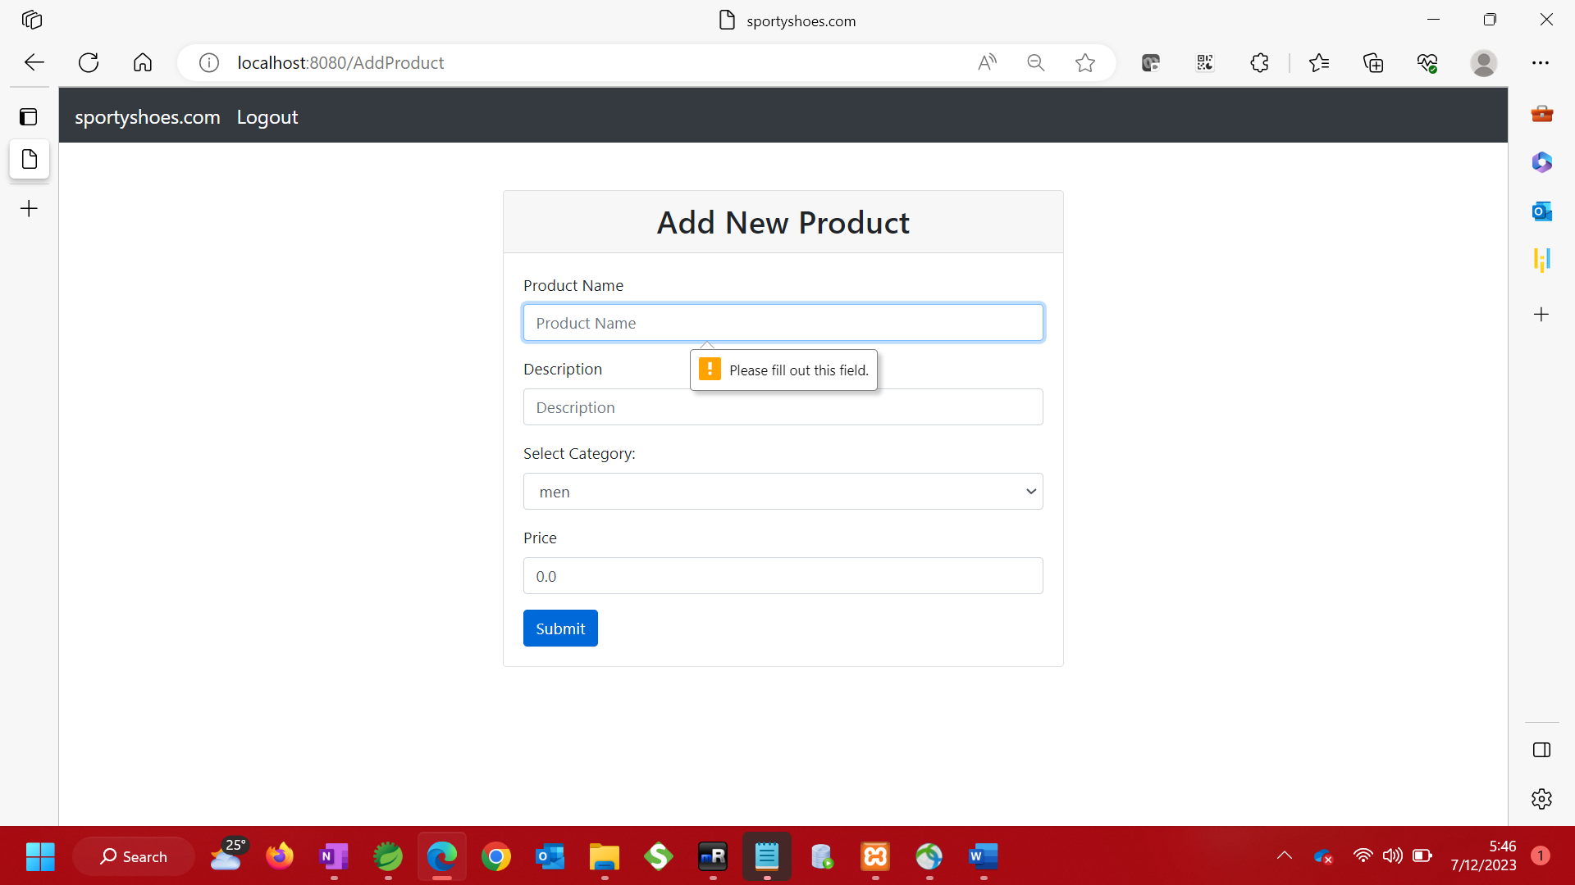

ii. If input is not empty, submit to database and redirect to view products page to view the new product added

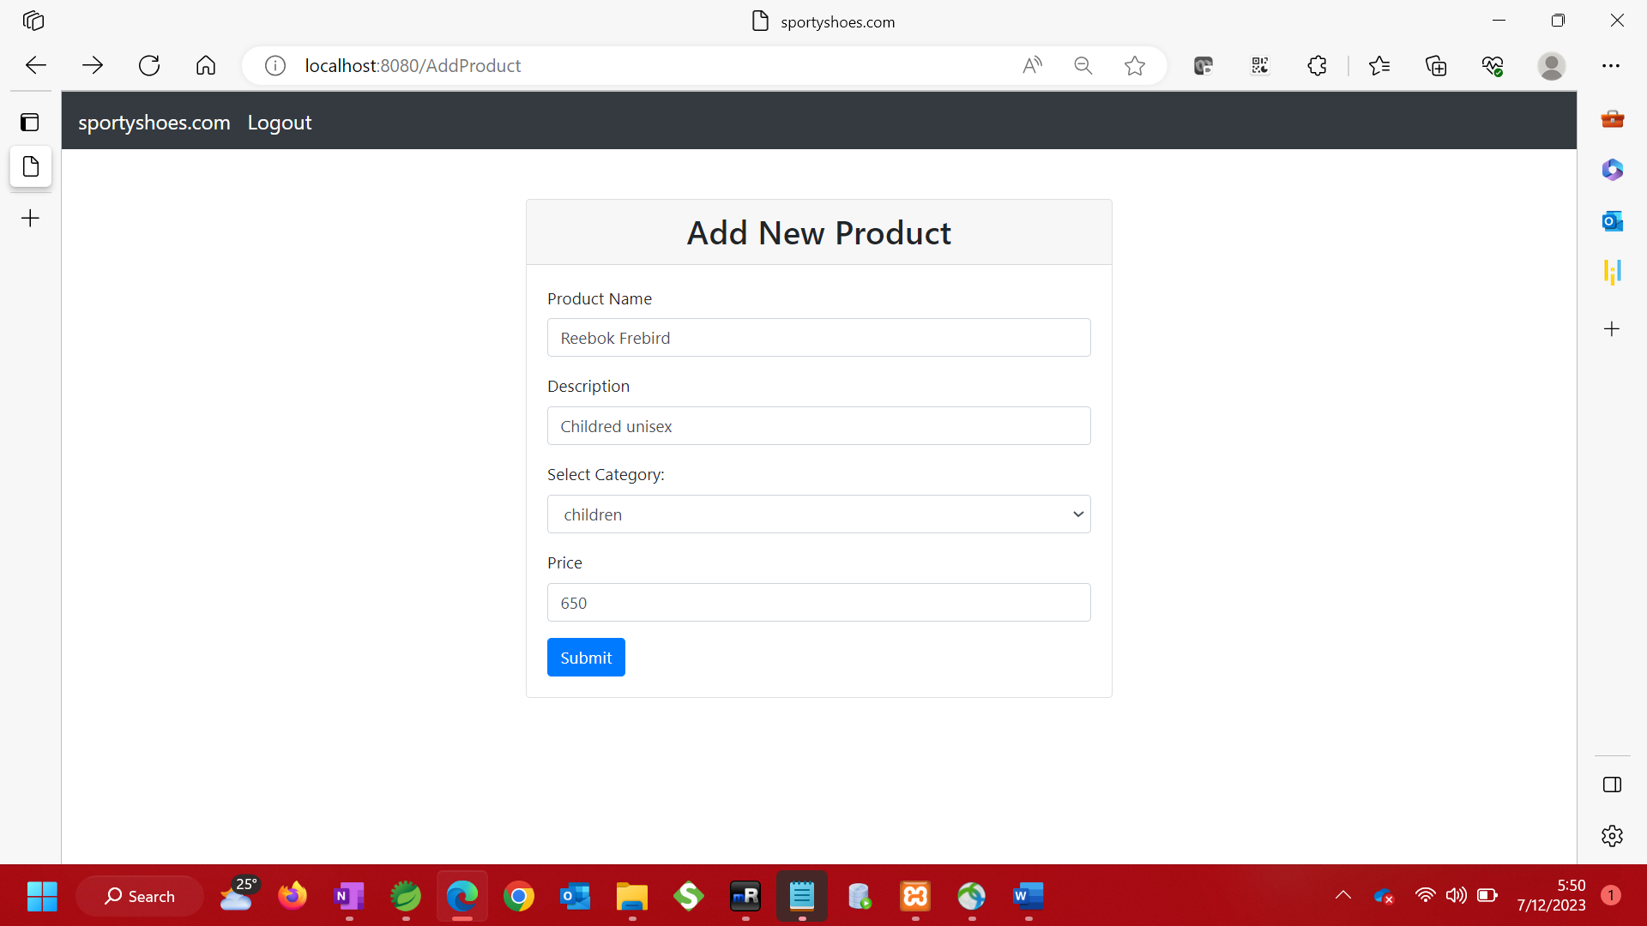

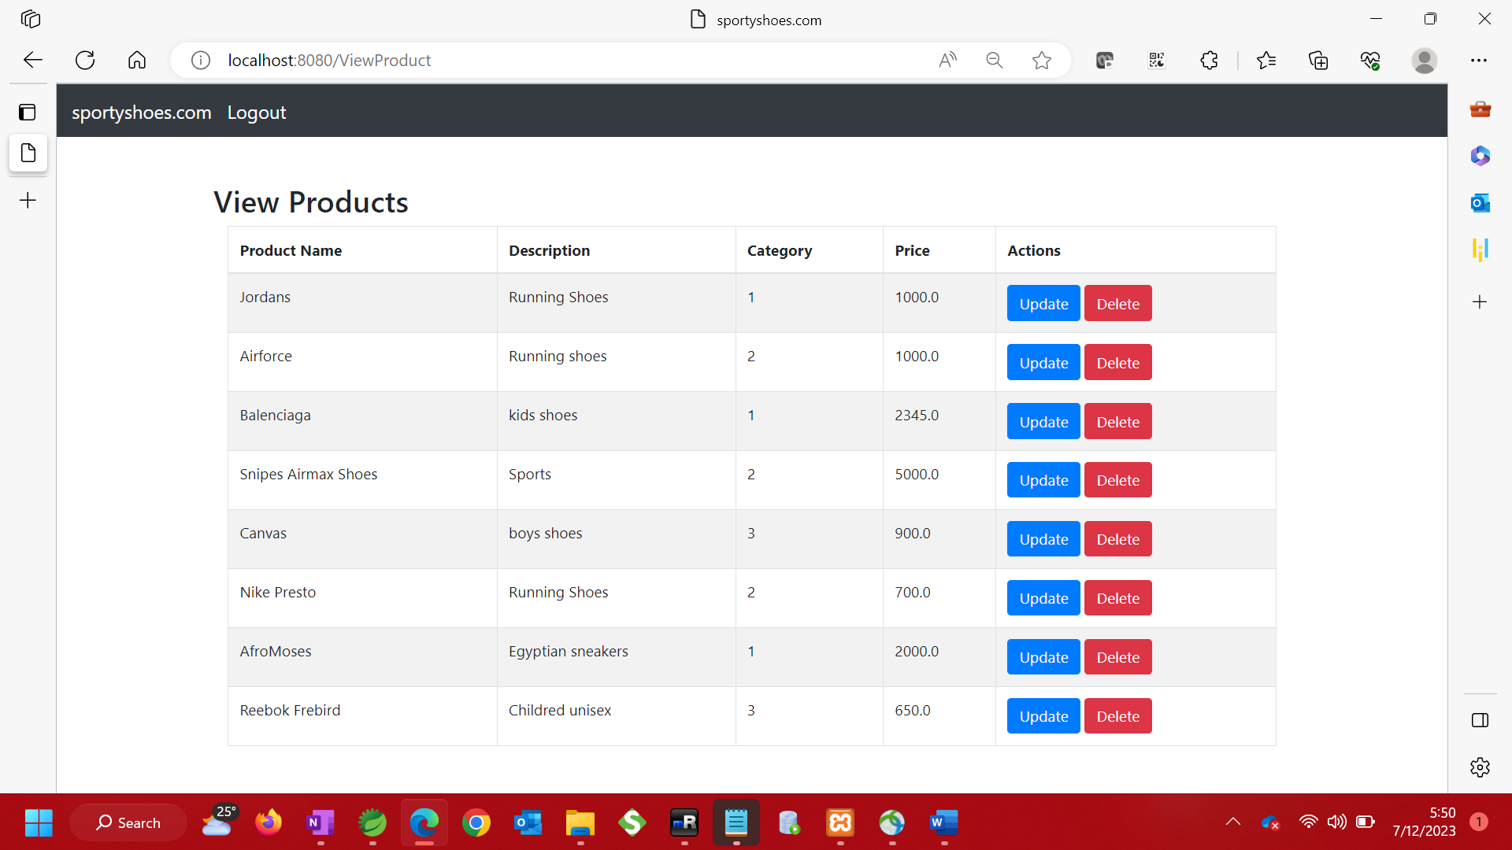

1. Update Product Details

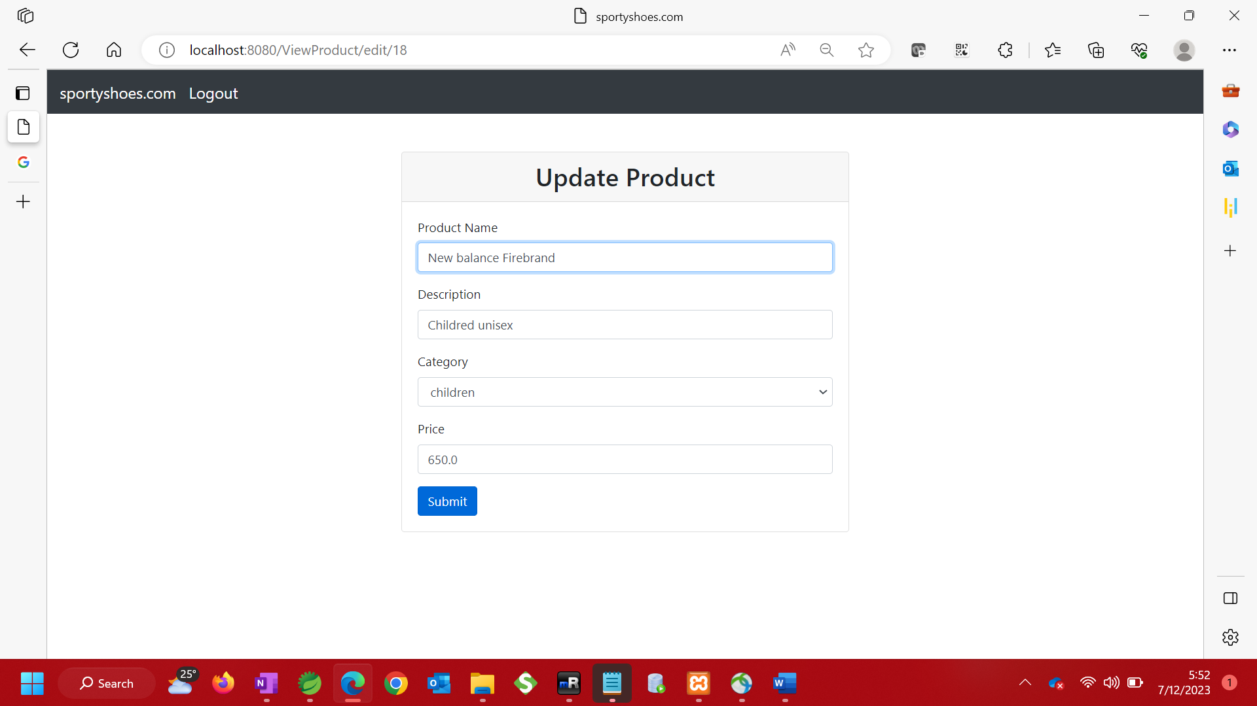

1. Update Category

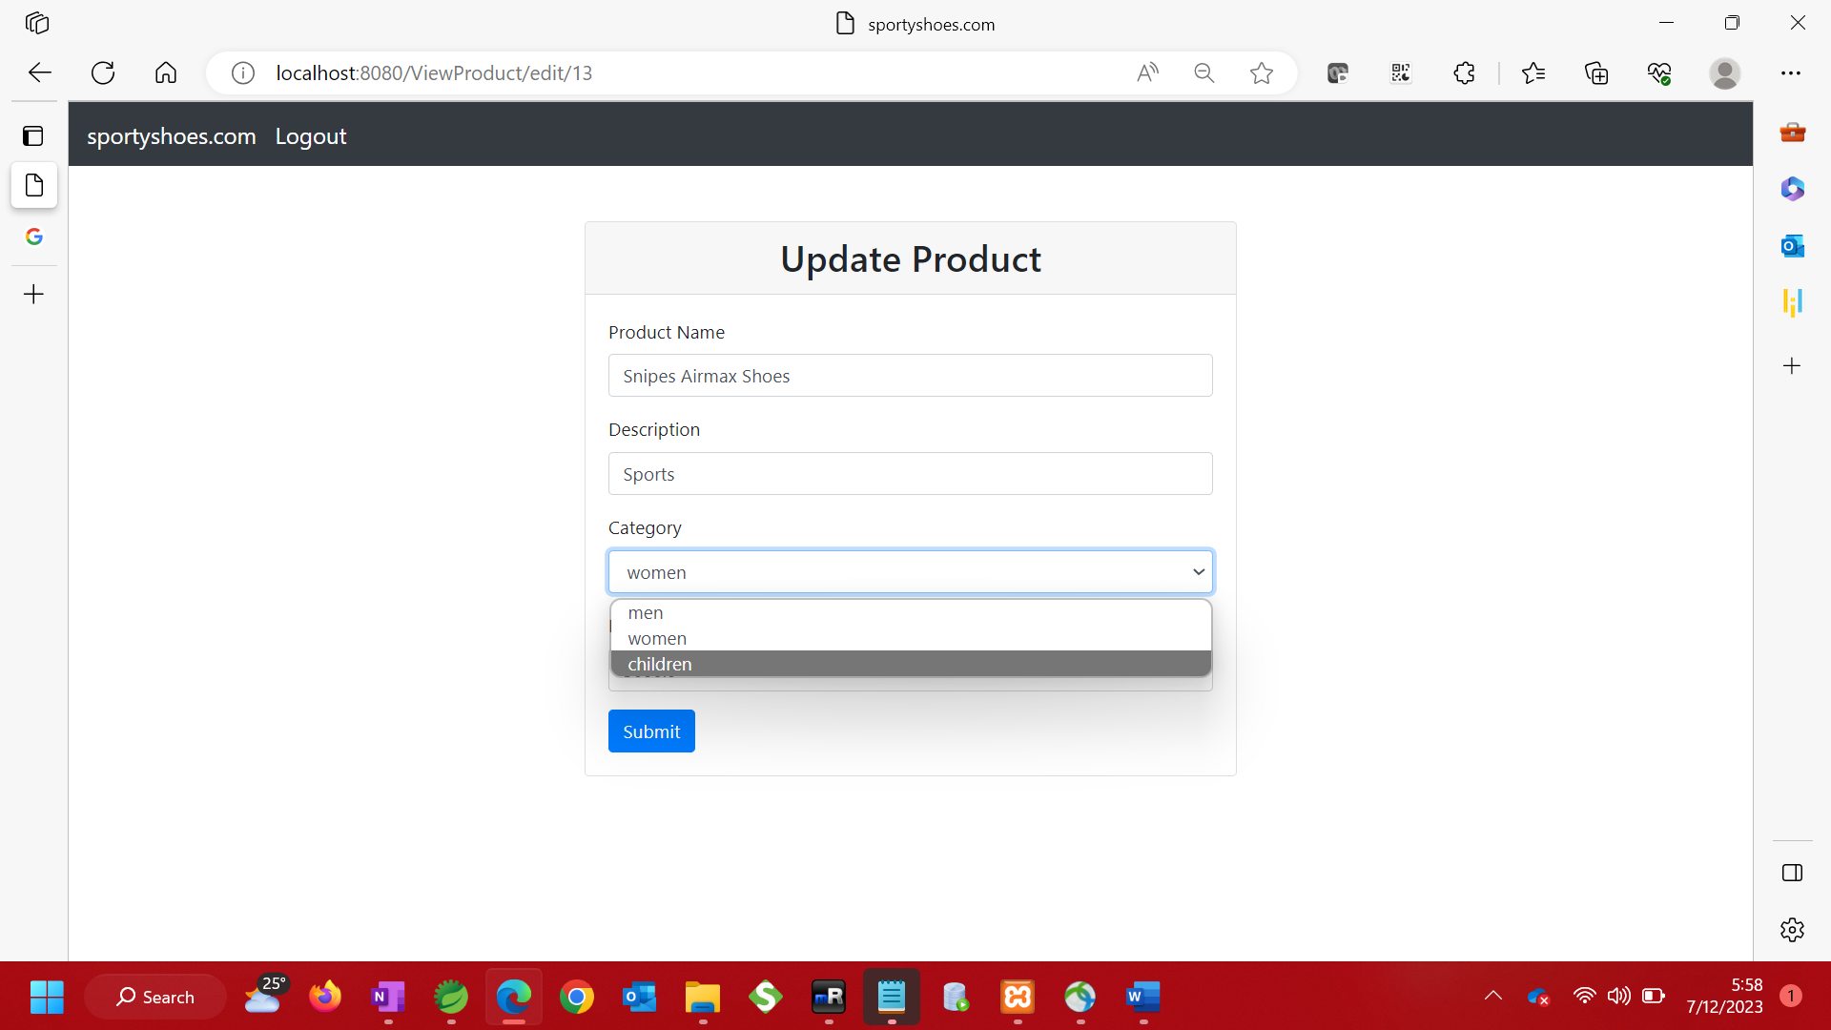

1. Show updated product details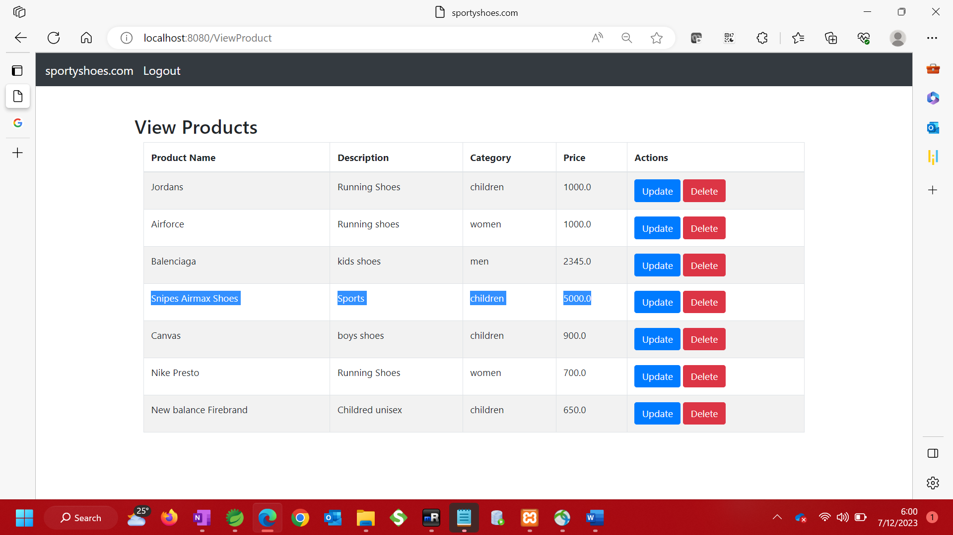
2. Delete product

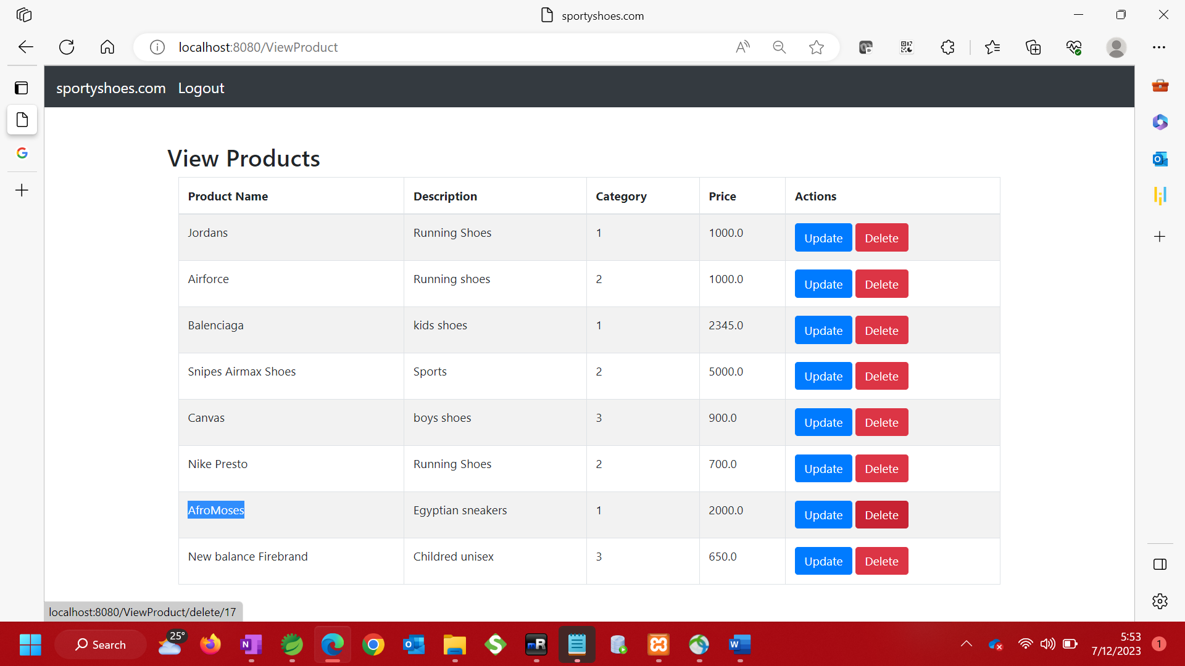

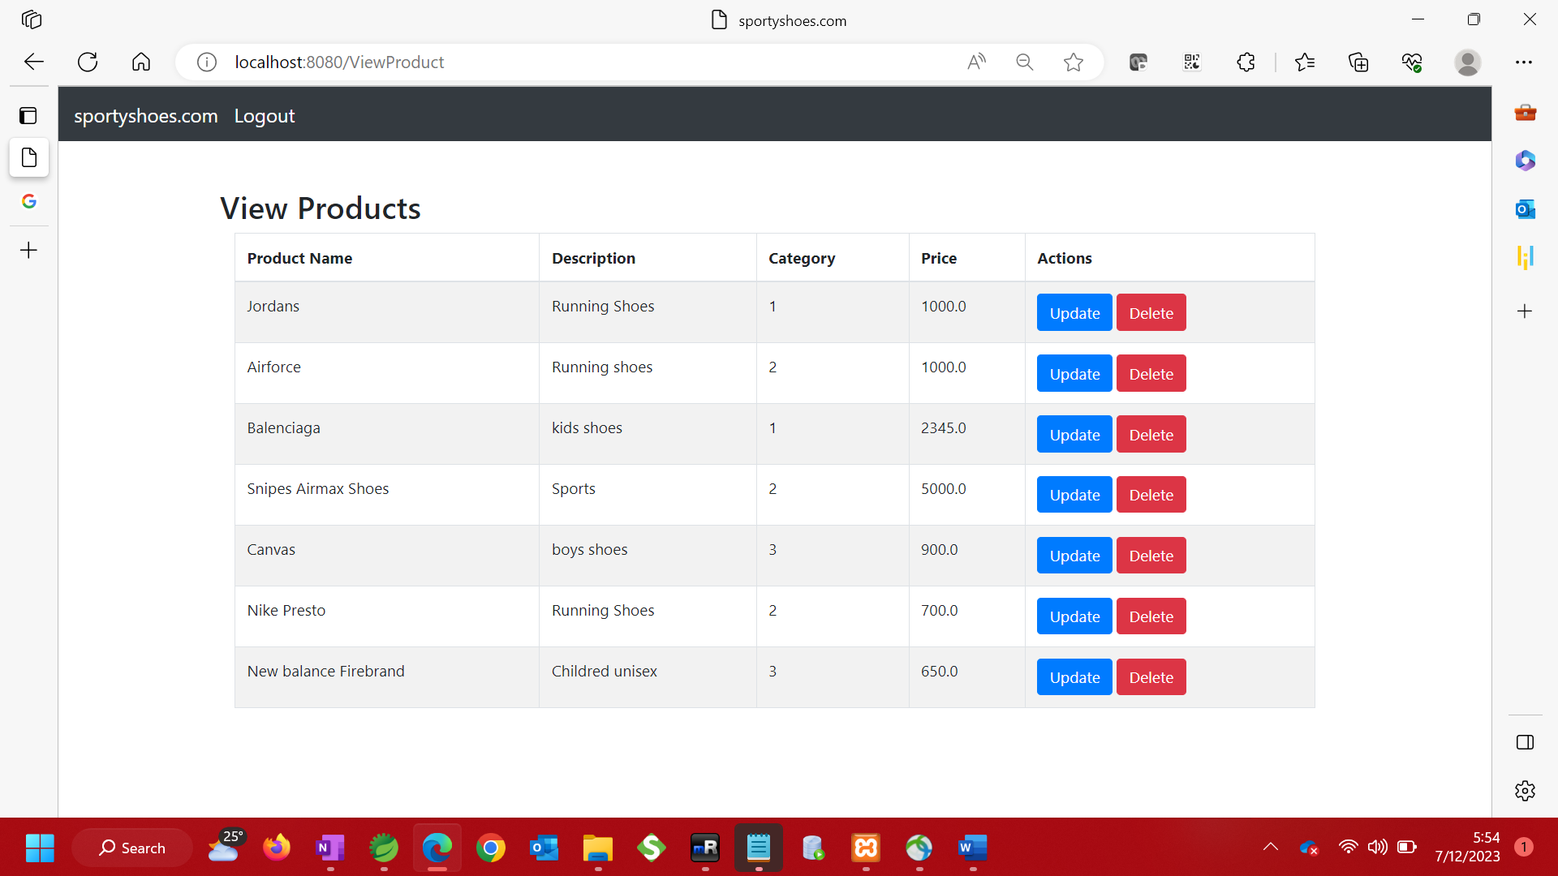

1. Browse users – Admin is able to view all users

. 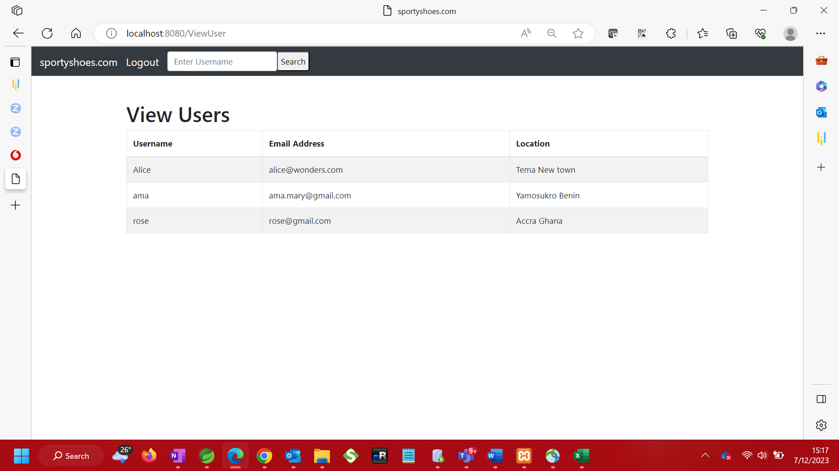

1. Search by username

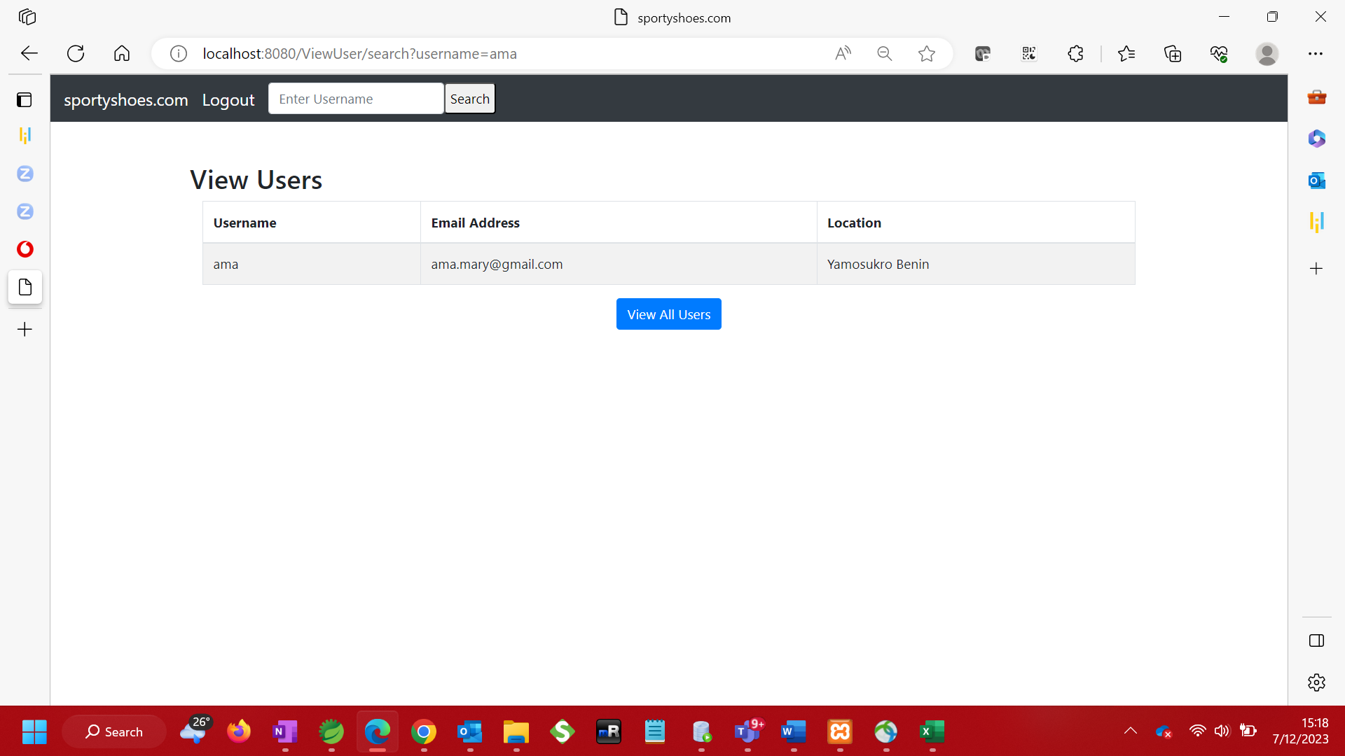

1. View purchase report

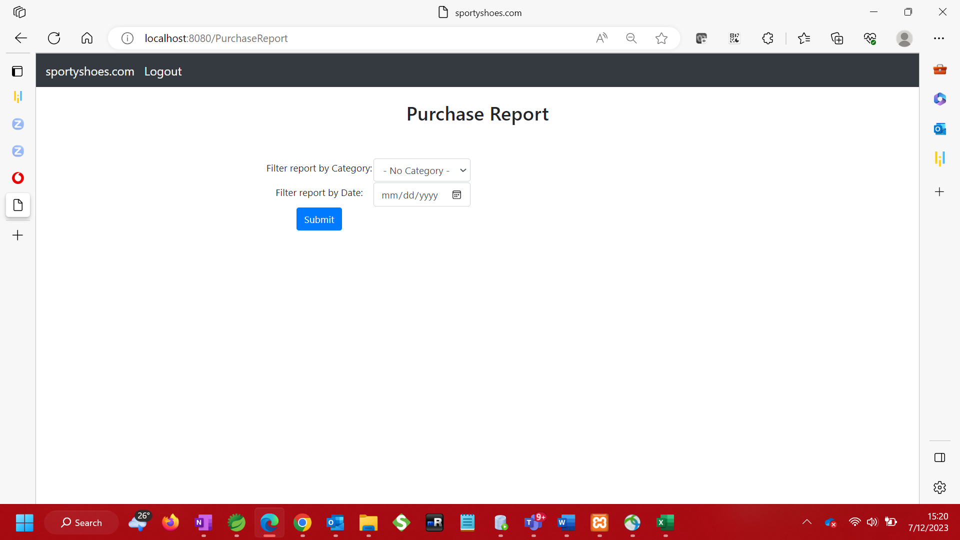

1. Filter purchase report by Date or by Category

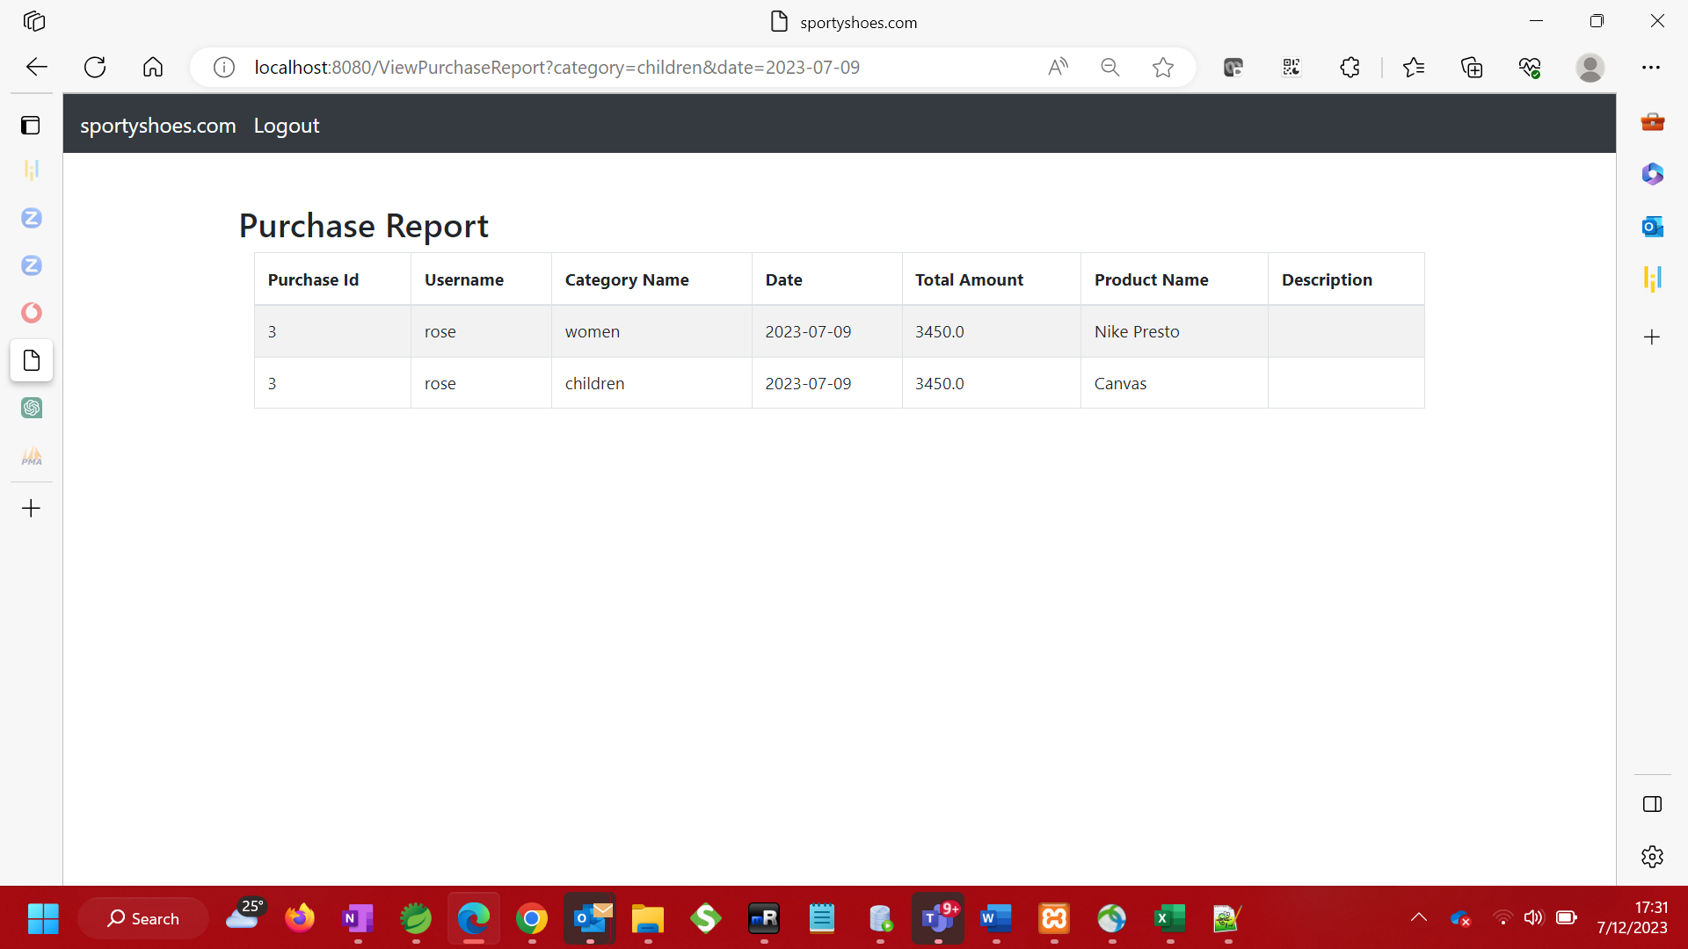

1. Logout of the application.

